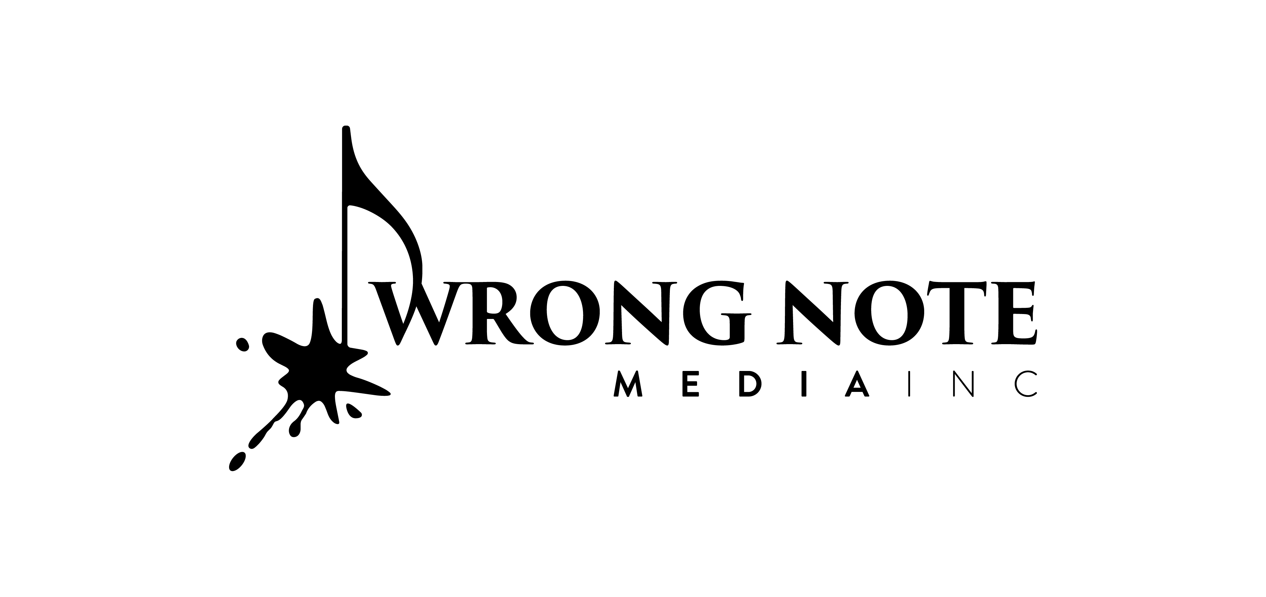
Post Office Box 122
Midland, Pennsylvania USA

TODD GOODMAN
composer

TODD GOODMAN (b. 1977) is a prominent figure in the contemporary classical music scene, pushing the boundaries of the genre with his unique style and vision. His music is performed and recorded around the globe by musicians of all levels—including, world-renowned soloists, top-tier professional ensembles, academic ensembles, and learners of all ages. Dr. Goodman has been the recipient of numerous awards, grants, commissions, and honors from organizations such as the American Prize, the British Trombone Society, the International Tuba Euphonium Association, the National Endowment for the Arts, New Music America, and many others. As an advocate for arts education, Goodman has served for over two decades in various compositional and educational residencies with orchestras, opera companies, performing arts centers, and academic institutions around the United States, and was a nominee for the very first Educator of the Year Grammy™ Award.

Recordings of Goodman’s music can be found on Wrong Note Media, Potenza, Hello Stage, Arts Laureate, Duquesne University Press, Bridge, and Push Records. Goodman holds degrees from the University of Colorado at Boulder, Duquesne University, and Kent State University, and has studied at l’École Normale de Musique in Paris, France, and the Aspen Music Festival in Aspen, Colorado. He currently resides outside of Pittsburgh, Pennsylvania.

More information about Todd Goodman can be found at www.WrongNoteMedia.com and ToddGoodmanComposer.com.

