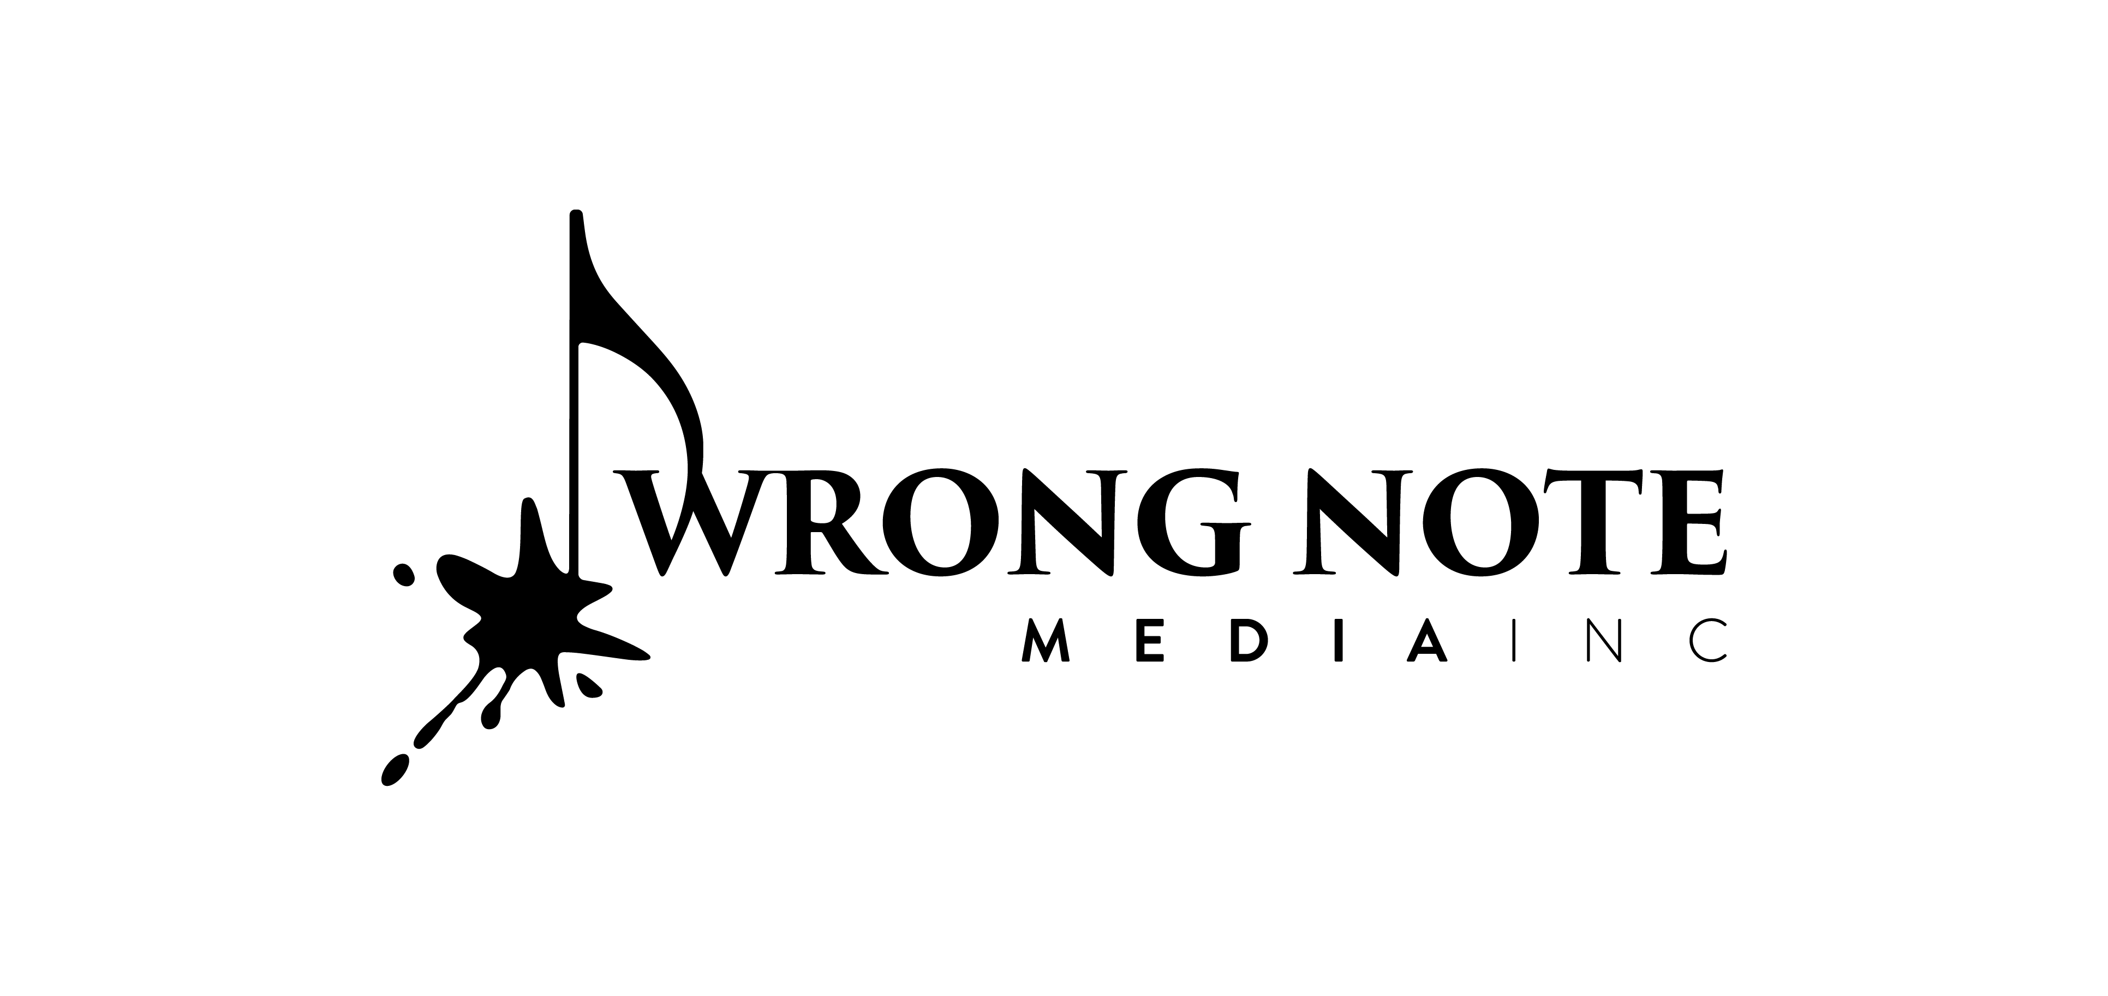
Post Office Box 122
Midland, Pennsylvania USA

TODD GOODMAN
composer

TODD GOODMAN (b. 1977) is a prominent figure in the contemporary classical music scene, pushing the boundaries of the genre with his unique style and vision. His music is performed and recorded around the globe by musicians of all levels—including, world-renowned soloists, top-tier professional ensembles, academic ensembles, and learners of all ages. Dr. Goodman has served as the resident composer for the Lincoln Park Performing Arts Center (2006-2019), The Microscopic Opera Company (2013), the Beaver Valley Philharmonic (2006-2007), the Altoona Symphony Orchestra (2002-2006), and the McKeesport Symphony Orchestra (2005-2006). As an advocate of arts education, Dr. Goodman was a nominee for the very first Educator of the Year Grammy™ Award, and he currently serves as the Chief Academic Officer for the Lincoln Park Performing Arts Center where he is the creative force behind the development of their arts-centric courseware.
Todd Goodman’s awards, grants, and honors are numerous, including honorable mention for the 2023 American Prize for Orchestral Composition for his Tuba Concerto No. 2, “This Too Shall Pass,” which was also a finalist for the 2023 International Harvey Phillips Award for Excellence in Composition. Goodman is no stranger to the American Prize and the Harvey Phillips Award, winning the Theater Composition American Prize in 2014 for his opera Night of the Living Dead (2013), third prize for the 2011 Orchestral Composition American Prize for his Concerto for Bass Clarinet (2008), and his Tuba Concerto (2012) was a finalist for the 2012 Harvey Phillips Award. In 2013, Night of the Living Dead, the opera was selected as one of the Center for Contemporary Opera’s New Works Showcase, receiving its New York City debut. Goodman also received the 2011 British Trombone Society Composition Award for his Trombone Concerto (2011), the 2007 prize from the International Project Piccolo Rebirth for Echos: prelude and dance (2007), two prestigious Gold Farbe Awards from the University of Colorado film department for his scores to two short films Hypnotic Reverie and Light Autumn by writer/director Ryan McVeigh, and many ASCAPlus Awards. His music has been supported by awards and grants from the National Endowment for the Arts, the American Music Center, New Music America, and the Universities of Delaware, South Florida, and Colorado. And most recently, Dr. Goodman was named to the Beaver Valley Musicians Hall of Fame.

Todd Goodman was born in Bedford, Pennsylvania, in 1977. He earned his Bachelor of Music degree in composition from the University of Colorado at Boulder, a Master of Music degree in composition from Duquesne University in Pittsburgh, Pennsylvania, and dual Ph.D.s in theory and composition from Kent State University. He has also studied at l’École Normale de Musique in Paris, France, with the European American Musical Alliance and at the Aspen Music Festival in Aspen, Colorado. His principal composition teachers have been Pulitzer Prize-winning composer George Tsontakis as well as David Stock, Frank Wiley, and Richard Toensing.

Todd Goodman’s available recordings are numerous. His Tuba Concerto was recorded on the award-winning 2022 album Storyteller by Justin Benavidez and the Florida State Symphonic Wind Ensemble. In 2019, his trio Wanderlust was the title track on Eastern Standard’s debut CD, and his piece Sonata for Solo Bass Trombone was released with bass trombonist Matt Hoormann on Push Records. His Trombone Concerto was included on the 2017 release United on the Hello Stage label, performed by trombonist Peter Steiner and pianist Hsiao Ling Lin. Also in 2017, Arts Laureate released the University of Delaware Wind Ensemble recording of Goodman’s Trombone Concerto No. 2 with soloist Bruce Tychinski. In 2014, Potenza Music Company included the University of South Florida Orchestra recording of his Concerto for Bass Clarinet and Orchestra with soloist Calvin Falwell and conductor William Weidrich on their release Fine Tune. Also on the Potenza Music Company is Goodman’s Tuba Concerto, recorded by Grammy™-nominated tubist Aaron Tindall and pianist Margaret McDonald. His wind ensemble piece River of Sorrows was recorded by the Duquesne University Wind Symphony and conducted by Robert Cameron and released in 2006 by Duquesne University Press on their release Winds of Summer. The world premiere of his Symphony No. 1 “Fields of Crimson,” recorded by the Altoona Symphony Orchestra conducted by Nicholas Palmer, was released through Wrong Note Media, Inc. in July 2003, marking the 140th anniversary of the subject of this work, the Battle of Gettysburg. New releases scheduled for 2023 are the world-premiere recordings of the piano reduction to his Trombone Concerto No. 2 by the Portugal Symphony’s principal trombonist Hugo Assunção; Dear Tomorrow for euphonium and piano by Klemens Vetter; Departure for trombone, tuba, and piano quartet by members of the Portugal Symphony; and a feature disc of the piano reductions of his three woodwind concerti—alto saxophone, piccolo, and bass clarinet.

Goodman’s current projects include Victoriam: a concerto for horn, tuba, and piano with orchestra and Seeing Double: a concerto for alto flute and English horn with orchestra, both works are commissioned by consortiums of performers, conductors, orchestras, students, and universities from around the world. For information on these projects, please visit ToddGoodmanComposer.com.

Dr. Goodman now resides in Midland, Pennsylvania, with his wife, Katie; sons, Emmerson and Foster; their St. Bernard, “Einstein;” and their pug, “Peep.”

For more information about Todd Goodman and to peruse his music, please visit www.WrongNoteMedia.com.

